Security of Mobile Banking

Kelvin Chikomo, Ming Ki Chong, Alapan Arnab, Andrew Hutchison
Data Networks Architecture Group
Department of Computer Science
University of Cape Town
Rondebosch 7701, South Africa
{kchikomo, mchong, aarnab, hutch}@cs.uct.ac.za

ABSTRACT
Mobile banking is attractive because it is a convenient approach to perform remote banking, but there are security shortfalls in the present mobile banking implementations. This paper discusses some of these security shortfalls, such as security problems with GSM network, SMS/GPRS protocols and security problems with current banks’ mobile banking solutions. This paper discusses the SMS and GPRS proposed solutions for these problems. The results from these proposed solutions have proven to provide secure and economic communications between the mobile application and the bank servers.The proposed solutions allow the users to bank using secure SMS and GPRS.
Categories and Subject Descriptors
C.2.0 [Computer-Communication Networks]: Network General – Data communications, Security and protection.
K.4.4 [Computers and Society]: Electronic Commerce – Payment schemes, Security.
C.2.2 [Computer-Communication Networks]: Network Protocols – Applications.
General Terms
Design, Reliability, Security, Standardization
Keywords
Mobile Banking, SMS Protocol, GPRS Protocol

INTRODUCTION
In the past decade, the number of online banking users has increased rapidly. This has led many developers to investigate more convenient methods for customers to perform remote banking transactions. Mobile banking is a new convenient scheme for customers to perform transactions, and is predicted to increase as the number of mobile phone users increases.
At the moment South African banks like Standard Bank and FNB provide mobile banking through two channels: through the WAP (Wireless Application Protocol) over GPRS (General Packet Radio Service) and SMS (Short Message Service) using the WIG (Wireless Internet Gateway).
In this project, we investigate the security threats in mobile banking implementations using the GSM network. The goal of this project is to build applications for portable devices that ensure users can securely send their banking information via the GSM network. The mobile banking solutions developed provide platforms for users to bank using SMS and GPRS.
In section 2, we provide an overview of the current GSM architecture and the security vulnerabilities of the architecture. In section 3, we discuss the current mobile banking solutions provided by banks in South Africa and their security shortfalls. In section 4 and 5, we present the proposed solutions for secure SMS/GPRS banking protocol. In section 6, we provide a comparison table between current mobile banking solutions and the proposed solutions. In section 7 and 8, we conclude our research and discuss some of the possible future work to extend this research.

GSM AND GPRS SECURITY ARCHITECTURE
Global System for Mobile Communications (GSM) is the most popular standard for mobile phones in the world. Figure 1 shows the basic structure of the GSM architecture; GSM provides SMS and GPRS (General Packet Radio Service) services.
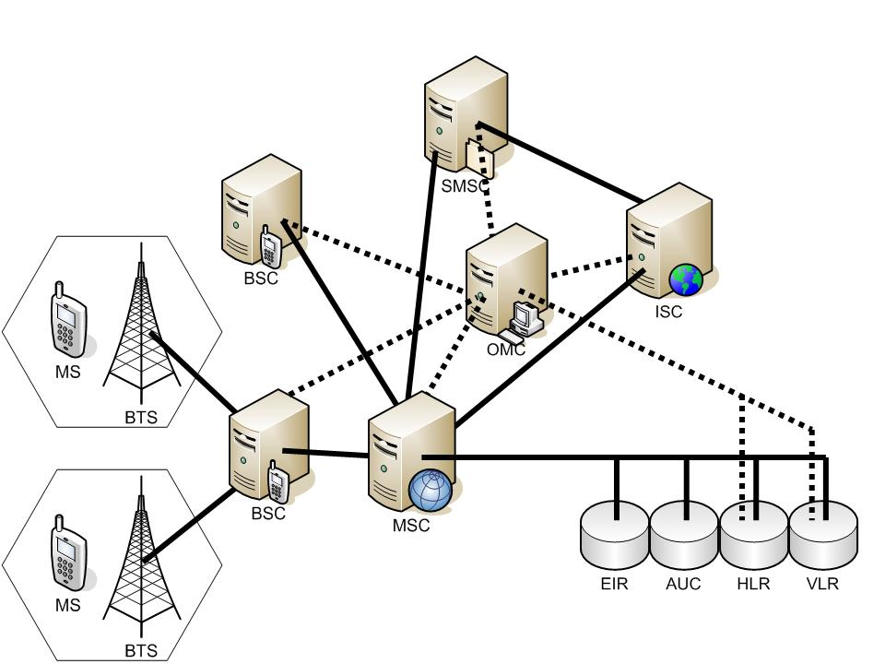
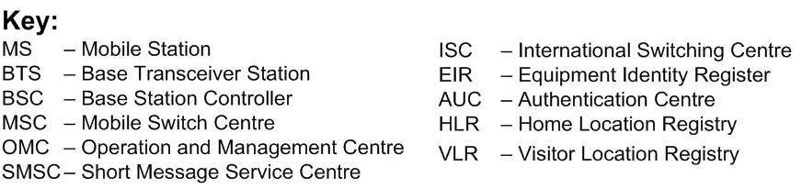
Figure 1. GSM Architecture
The GPRS Core network is an integrated part of the GSM network; it is layered over the underlying GSM network, with added nodes to cater for packet switching. GPRS also uses some of the existing GSM network elements; some of these include existing Base Station Subsystems (BSS), Mobile Switching Centers (MSC), Authentication Centers (AUC), and Home Location Registers (HLR). Some of the added GPRS network elements to the existing GSM network include; GPRS Support Nodes (GSN), GPRS tunneling protocol (GTP), Access points, and the (Packet Data Protocol) PDP Context.

Security mechanisms in the GSM network
The GSM network has some security mechanism to prevent activities like Subscriber Interface Module (SIM) cloning, and stop illegally used handsets. GSM has methods to authenticate and encrypt data exchanged on the network.

GSM Authentication Center
The GSM authentication center is used to authenticate each SIM card that attempts to connect to the GSM network. The SIM card authentication takes place when a mobile station initially attempts to connect to the network, i.e. when a terminal is switched on. If authentication fails then no services are offered by the network operator, otherwise the (Serving GPRS Support Node) SGSN and HLR is allowed to manage the services associated with the SIM card.

Authentication Procedure
The authentication of the SIM depends on a shared secret key between SIM card and the AUC called Ki. This secret key is embedded into the SIM card during manufacture, and it is also securely replicated into the AUC.
When the AUC authenticates a SIM, it generates a random number known as the RAND. It sends this RAND number to the subscriber. Both the AUC and SIM feed the Ki and RAND values into the A3/A8 (or operator proprietary algorithm (COMP128)) and a number known as Signed RESponse (SRES) is generated by both parties. If the SIM SRES matches the AUC SRES the SIM is successfully authenticated.
Both the AUC and SIM can calculate a second secret key called Kc by feeding the Ki and the RAND value into the A5 algorithm. This would be used to encrypt and decrypt the session communications.
After the SIM authentication the SGSN or HLR requests the mobile identity, this is done to make sure that the mobile station being used by the user is not black listed. The mobile returns the IMEI (International Mobile Equipment Identity) number; this number is forwarded to the EIR (Equipment Identity Register). The EIR authorizes the subscriber and responds back to the SIM with the status, if the mobile is authorized the SGSN informs the HLR and PDP Context activation begins.

Problems with GSM Network

Problems with the A3/A8 authentication algorithm
A3/A8 is the term used to describe the mechanism used to authenticate a handset on a mobile phone network [1]. A3 and A8 are not actually encryption algorithms, but placeholders. In A3/ A8 the commonly used algorithm is COMP128 [1].
COMP128 was broken by Wagner and Goldberg in less than a day [3]. This raises concerns of having GPRS as a secure communication mechanism. After cracking COMP128 Wagner and Goldberg went on to prove that it was possible to obtain the Ki value, therefore making it possible to perform SIM cloning. There has been a release of COMP128-2 and COMP128-3 to cater for some of the SIM cloning issues, but the majority of the SIMs still being used use COMP128.
These security threats illustrate some of the security issues which should be rectified if GPRS is to be used as a secure medium for mobile banking.

Problems with A5 algorithm
The A5 algorithm is used to prevent casual eavesdropping by encrypting communications between mobile station (handset) and BSS. Kc is the Ki and RAND value fed into the A5 algorithm. This Kc value is the secret key used with the A5 algorithm for encryption between the mobile station and BSS.
There are at least three flavours of the A5 algorithm. These include A5/1 which is commonly used in western countries. The A5/1 is “deemed ‘strong’ encryption” [3] but it was reverse engineered some time ago. A5/2 has been cracked by Wagner and Goldberg, the methodology they used required five clock cycles making A5/2 almost useless. Finally A5/0 is a form of A5 that does not encrypt data at all.
All these problems with the A5 encryption algorithms prove that eavesdropping between mobile station and BSS is still possible, making GPRS over the GSM core network very insecure for mobile banking.

Attack on the RAND value
When the AUC attempts to authenticate a SIM card, the RAND value sent to the SIM card can be modified by an intruder failing the authentication. This may cause a denial of service attack [3].

CURRENT MOBILE BANKING
In this section, we look at the security shortfalls of the current mobile banking solutions using the short message service (SMS).

Current SMS Banking Services in South Africa
Currently South African banks, such as Standard Bank and ABSA use the Wireless Internet Gateway (WIG) for mobile banking. First National Bank (FNB) uses the Unstructured Supplementary Services Data (USSD) with SMS approach. FNB requires the user to first send a USSD string with the user’s PIN to the banking server. Then the server returns a message to notify the user that the server is ready to accept banking SMS message. This approach is not secure because every user’s detail is transmitted in plaintext. The mobile network operator has full access into the banking details sent by the user.

Security Problems with SMS
The initial idea for SMS usage was intended for the subscribers to send non-sensitive messages across the open GSM network. Mutual authentication, text encryption, end-to-end security, non-repudiation were omitted during the design of GSM architecture [3]. In this section we discuss some of the security problems of using SMS.

Forging Originator’s Address
SMS spoofing is an attack that involves a third party sending out SMS messages that appear to be from a legit sender. It is possible to alter the originator’s address field in the SMS header to another alpha-numerical string. It hides the original sender’s address [1] and the sender can send out hoax messages and performs masquerading attacks.

SMS Encryption
The default data format for SMS messages is in plaintext. The only encryption involved during transmission is the encryption between the base transceiver station and the mobile station. End-to-end encryption is currently not available. The encryption algorithm used is A5 which is proven to be vulnerable [3]. Therefore a more secure algorithm is needed.

Current GPRS Implementations

Present GPRS banking implementations
In South African there are five banks offering mobile banking using GPRS: Standard Bank, FNB, Absa, Nedbank, and Investec. Of these banks four are using the MTN mobile banking gateway. MTN mobile banking allows bank account holders to access WAP sites and perform banking the same way they would carry out internet banking.

Wireless Application Protocol (WAP)
WAP is an open international standard for applications that uses wireless communication. Its principal application is to enable access to the internet from a mobile phone or PDA [4]. Mobile phones or terminals can access the internet using WAP browsers; WAP browsers can only access WAP sites. Instead of the traditional HTML, XML or XHTML, WAP sites are written in WML (Wireless Markup Language). The WAP protocol is only persistent from the client to the WAP gateway, the connection from the WAP Gateway to the Bank Server is secured by either SSL or TLS. Figure 2 below illustrates this architecture.
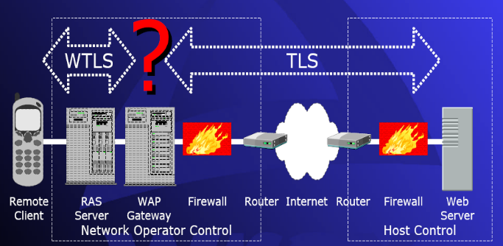
Figure 2. WAP in relation to external networks. Source from Ric Howell
WAP provides security of communications using the WTLS (WAP Transport Layer Security) protocol and the WIM (WAP Identity Module). WTLS provides a public-key based security mechanism similar to TLS and the WIM stores the secret keys. In order to allow the interoperability of WAP equipment and software with many different technologies WAP uses the WAP protocol suite. Figure 3 illustrates the different layers of the WAP protocol.
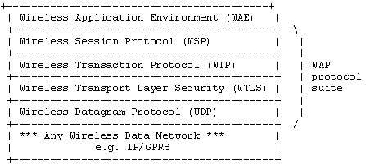
Figure 3. WAP Protocol Suite Source from [6]

Security problems with Current GPRS Implementations

Security issues with present implementations that use WAP
The present mobile banking implementations that are using WAP have proven to be very secure, but there exist some loopholes which could lead to insecure communications. Some of these loopholes include:
- There is no end-to-end encryption between client and bank server. There is end-to-end to encryption between the client and the Gateway and between the Gateway and the Bank Server. To resolve this, the bank server could have its own Access Point Name (APN) in any of the GPRS networks. This APN would serve as the WAP Gateway for the bank. Therefore the client would be connected directly to the bank without third parties in the middle of the communication.
- Public key cryptosystems key sizes offered by the WTLS standard are not strong enough to meet today’s WAP applications’ security requirements. Considering the low processing power of the handheld devices, the key sizes have been restricted [5].
- Anonymous key exchange suites offered by the WTLS handshake are not considered secure. Neither client nor the server is authenticated. Banks should provide functionality to disallow this option of handshaking.

Security issues associated with using the plain GPRS network
The GPRS core network is too general; it does not cater for some banking security requirements. Some of these requirements include:
- Lack of account holder or bank authentication. The Bank can provide a unique APN to access the Bank server, but without this or some other authentication mechanism anyone can masquerade as the Bank. All these issues raise concerns of fabrication of either bank information or account holder information
- Provision of functions to avoid modification of data and ensure the integrity of data for both the account holder and the Bank.
- The methods to cater for confidentiality of data between the mobile station and the bank server have proven to be weak, and the network operator can view account holder’s information. This raises security issues for both the bank and account holder.
- The bank cannot prove that the account holder performed a specific action and the account holder cannot prove that the bank performed a specific action.
- GPRS provides session handling facilities, but does not handle Bank specific sessions; this may cause inconsistencies on the bank’s side raising security issues.

SECURE SMS SOLUTION
The solution provides a secure messaging protocol that uses SMS. The secure messaging protocol overcomes the existing security shortfalls in the GSM architecture. The messaging protocol has been integrated with mobile banking system so as to improve the security of SMS banking.
For demonstration purposes, three types of transactions have been simulated in this project. These transactions are: check balance, transfer money and purchase airtime. The types of transaction can change depending on the types of services provided by the bank.

Secure SMS Protocol

Message Structure
The secured SMS message is divided into multiple fields to accommodate for the various security checks required for the protocol. To ease the understanding of the message structure, Figure 4 shows the structure overview for a secure SMS message. The numbers above the fields are the minimum number of bytes required for each field in the message. The number of bytes for each field can be increased depending on the implementation requirements.
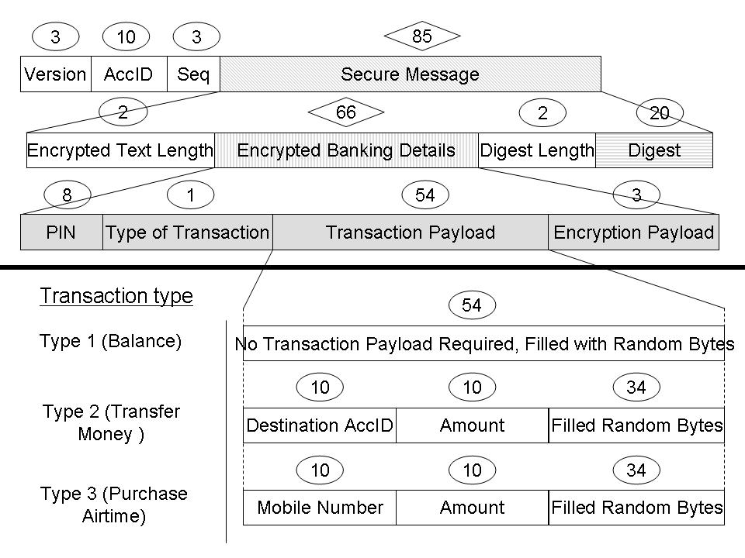
Figure 4. The Structure of a Secure SMS Message
The use of each labelled structure is explained below:
- The Version is the mobile application version number. It contains a specified bytes pattern. The receiver checks if the first three bytes of the received SMS message are valid for the bank application. If the message version number does not match the application version, then the message is discarded. As there are possibilities that the server can receive accidental SMS messages that are not intended for the bank server. The usage of the version bytes is to help to eliminate these erroneous messages.
- The AccID contains the bank account identifier of the user.
- The Seq is the user’s current sequence number of the one-time password.
- The Encrypted Text Length contains the number of next bytes that are the ciphered message.
- The Digest Length contains the number of next bytes that contains the message digest.
- The Digest contains the calculated digest value of the message. The use of the digest is for the server to check for message integrity. For the secure SMS banking protocol, a single digest of the following fields is calculated: Version, AccID, Seq, PIN, Type of Transaction and Transaction Payload.

The content of the following fields is encrypted using the generated session key.
- The PIN contains the user predefined password. This is used by the receiver application to authenticate the user.
- The secure SMS message can be used for different types of transactions. The Type of Transaction is used by the bank server application to identify the type of transaction it should perform.
- The Transaction Payload is the extra data that is used for a transaction, but it is not used for any security purpose. The content of the Transaction Payload depends on the type of transaction requested. The structure of the payload depends on the type of transaction offered by the bank.

Protocol Sequences
In the GSM network, SMS messages are sent asynchronously to the receiver, because of this the Secure SMS protocol is asynchronous. The figure below illustrates the overview of the secure SMS protocol.
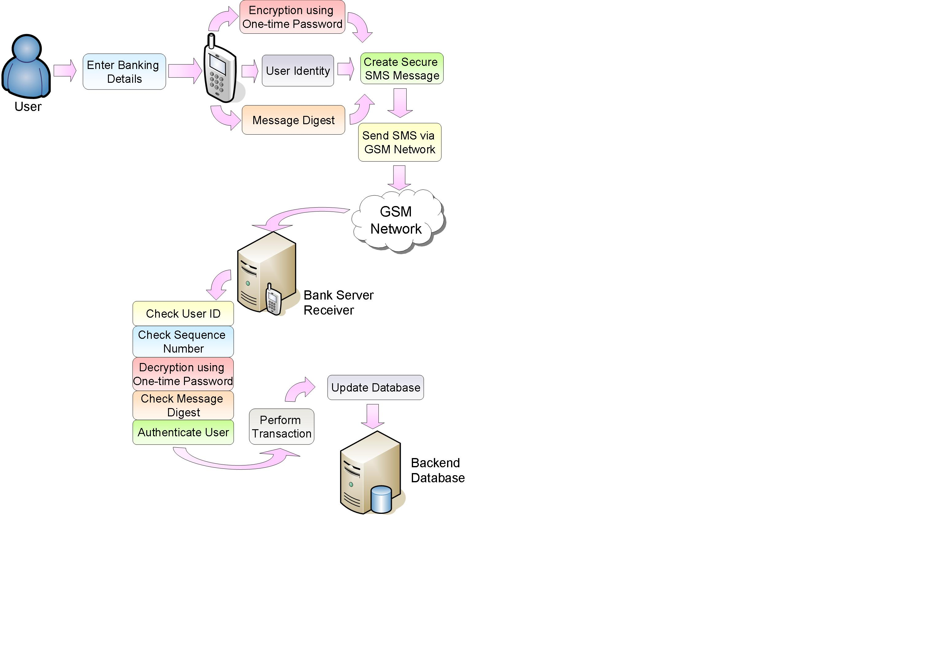
Figure 5. Protocol Overview
We can consider the Secure SMS protocol to be divided into two parts. The first part is the message generation. The mobile phone generates the message and sends it to the server. The second part is the message security checks. The server reads the received message, decodes the contents and performs security checks. The following subsections describe each part of the protocol.

Generating and Sending Secure SMS Messages
The mobile phone captures all the required security information from the user. This information is used to generate the secure SMS message to be sent to the server. The mobile application has a preset version bytes pattern, this pattern is inserted into the message.
The message hash value a number which can ensure message integrity for the receiver side. The requirement of maintaining the message integrity is that at least some of the contents that are used for calculating the message digest need to be encrypted. This can ensure message integrity because if the message is intercepted, the attacker cannot use the encrypted contents to generate another digest. The integrity validation will not pass if any part of the original message is altered.
The fields of content that need to be encrypted are dependent on the needs of the developer. The protocol requires that the message to have some identification details not to be encrypted. This is for the receiver to identify the account holder’s identity.
The algorithm used for encryption must be a symmetric encryption algorithm. The key used for encryption is generated from the one-time password entered by the user. The one-time passwords are only known by the server and the user.
After the application completes processing the security contents, the contents are placed in the SMS message according to the message structure described in the “Message Structure” section. The SMS message is sent to the server via the GSM network.

Receiving and Decoding Secure SMS Message
When the server receives the message from the cellular network, it breaks the message down according to the structure described in the “Message Structure” section.
The server first checks for the version bytes pattern. If the version is correct, it is assumed that the message is suitable for the secure SMS protocol. Next, the server reads the account identifier from the message and checks if the account identifier exists in the server database. After this, the server retrieves the current sequence number for the given account identifier. The server checks if the sequence number read from the message matches the sequence number read from the server’s database.
If the above security checks all passed, the server proceeds to retrieve the one-time password from the database. The password is indexed by the account identifier and the sequence number. Thereafter the server uses the retrieved password as the decryption key to decode the encrypted contents. If the decryption is successful, then the used one-time password is discarded and the server’s sequence counter for that account gets incremented by the value of 1.
After the decryption, the server reads the secure contents that are required for the calculation of the message digest. The message digest is calculated using the same algorithm as the algorithm used by the mobile application. The server compares the two digests for message integrity. If the message is proven not to have been altered, then the server retrieves the PIN (the account holder’s personal password) from the message and compares it against the account holder’s PIN from the server’s database.
If all of the above security checks pass, the server performs the requested transaction.

Security of the Secure SMS Protocol
The following subsections describe how the Secure SMS protocol conforms to the general security requirements.

Confidentiality
This is achieved by encrypting the message using a symmetric secret one-time password. The one-time password is only shared between the user and the bank server. The strength of the confidentiality depends on the security strength of the passwords generation algorithm used and the strength of the ciphering algorithm used. It is assumed that only the authorized user will know his/her list of passwords and the passwords are never shared with other people.

Integrity
The message digest is the hashed value of the message content calculated server application and the mobile phone application. If the content is altered during transmission, the hashing algorithm will generate a different digest value at the receiver side. If the digests mismatch, the receiver will know that the integrity of the message has been compromised. The strength of the integrity checks depends on the strength of the algorithm used to generate the digest value and it also depends on the strength of the encryption algorithm used to hide the confidential data.

Authentication
For the receiver to authenticate the user, the user must provide his/her authentication detail(s) to the receiver. This authentication process is performed by validating the message PIN with the receiver stored PIN. The PIN is previously selected by the user when the user registers for a mobile banking account. The strength of the authentication depends on the password selection strategies used.

Non-Repudiation
Only the account holder and the bank server are supposed to have the one-time password. The bank server does not generate the same one-time password more than once. Therefore every one-time password is unique in the server’s database. Each pair of one-time password and sequence number is only allowed to be used for a single user. Therefore the user cannot deny not sending the message because only that specific user has that unique pair of password and sequence number to encrypt the message. If the bank server can use the same sequence-password pair to decrypt the message, then it indicates that user must have sent the message.

Availability
The availability of this protocol depends on the availability of the cellular network. The time it takes for a message to be delivered depends on the density of network operator base towers.
The number of transactions that the server can handle at once depends on the hardware capability. If the server’s hardware can handle multiple incoming messages then the server can perform multiprocessing to accommodate for more requests. The protocol has no restriction on the type of hardware needed. Therefore it is up to the developers to decide the hardware specifications.

SECURE GPRS SOLUTION
In order to rectify the security problems mentioned above two solutions were proposed. The first solution extends the security features in the present WAP implementations and the second solution is a completely new GPRS security protocol.

Extension of present WAP implementations
To provide the bank with full control of the WTLS protocol, this solution lets the bank customers connect to its bank network through a customized WAP gateway which operates in its network realm. The customized WAP gateway disallows the following handshake options:
- Abbreviated handshake
- Server authenticated full handshake
- Anonymous key exchange suites
Figure 6 illustrates the ideal location of the WAP gateway for mobile banking.
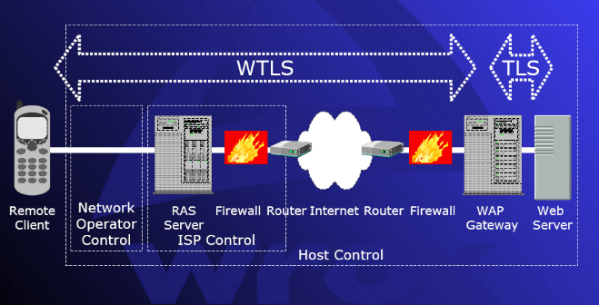
Figure 2. Ideal WAP Gateway setup for the bank server

New Secure GPRS protocol
The Secure GPRS protocol is a tunneling procedure that has been designed to take care of security in M-commerce applications. We have used this protocol to create and conduct secure connections between mobile devices and the bank servers. The Secure GPRS protocol consists of two main components; an initial client server handshake and the transfer of data packets (SGP record protocol) using the created secure tunnel and exchanged cipher suites. The SGP protocol uses some principles of pretty good privacy (PGP) as described in [7].

Protocol message components (Message Structure)
Each SGP message sent between the client and server has 3 components i.e. the message timestamp, message, and the message type. The message timestamp is used by both the client and server to prevent replay attacks, and the message type is also used by both the client and server to identify the message sent. Figure 9 below illustrates this message structure.
- Error message
- Handshake message
- Go-Ahead message

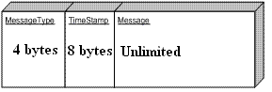
Figure 3.Structure of message sent

Client Protocol Initialization
When a client starts-up the mobile application a one time 512bits RSA key pair is generated. Once the keys have been generated the client sends its public key to the server. These keys are used in the protocol to create digital signatures for the client. These digital signatures are verified by the server using the sent client public key; this authenticates the messages sent by the mobile client. To complete the client protocol initialization the client generates a PBE AES session key using the client’s password.

User Authentication
The authentication takes place in two different sections; the first authentication is done by the mobile device and the second by the bank. When a user registers to use the banking service a server certificate signed using the client’s password is included as part of the application. This certificate is used to authenticate the account holder on the phone. When a user enters a password the phone application generates an AES key using this password. Using this key the application attempts to retrieve the server’s public key in the server’s certificate, if the server’s public key is retrieved successfully the initial client authentication is complete; else the client is asked to re-enter the password. Importantly the client is only allowed three login attempts; if the login fails in the three attempts the account is blocked.
The second user authentication is done by the server; the client sends its encrypted client account ID. The server then gets the password from the database and recreates the AES key; if it can successfully decode the encrypted message then the client is authenticated.

SGP handshake (Client)
The SGP handshake involves packing and sending a Full SGP packet to the server and the server being able to successfully decode the message and generate session keys. Figure 8 below illustrates the packing of the Full SGP packet.
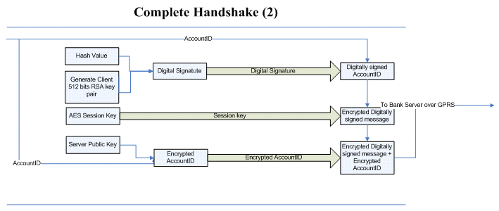
Figure 4.Packing of SGP message
Packing of the Full SGP packet starts-of with the client hashing the client account ID using SHA-1, the hashed account ID is then encrypted using the client’ private key in-order to create a client digital signature. The digital signature is then concatenated to the account ID to create a message digest. This is done to allow the server to detect any modification of data sent by the client. The message digest is then encrypted using the generated AES session key, in order to avoid eavesdropping from any third party. The mobile application then encrypts the client’s account ID using the server’s public key. This account ID is used by the server to retrieve the client’s password. Lastly the encrypted account ID and the encrypted message digest are concatenated and sent to the bank server.

Server Protocol initialization
When a server is started-up it initializes the necessary cipher parameters. On bank server start-up the administrator running the server has to login using a password which is used to retrieve the server’s private keys from the server’s keystore. This is done because all server private keys are saved in the server’s keystore signed using the administrator’s password.

SGP handshake (Server)
When a client creates a connection with the server, the first message the server receives is the client’s public key. After receiving the client’s public key, the server expects to receive the Full SGP message. When the server receives the full SGP message it splits the message into the encrypted message digest and encrypted account ID. Using its private key the server retrieves the sent account ID, and in turn retrieves the client’s password from the database. If the server fails to decrypt the message, or if the account ID sent is not in its database the server sends an error message back to the client. Figure 9 below demonstrates how the server unpacks and verifies the Full SGP packet sent by the client.
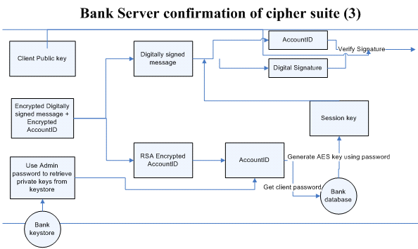

Figure 5.Server unpacking and verfying Full SGP message
The server then generates the session key using the retrieved password; the session key is used to decrypt the encrypted message digest. If the server fails to decrypt the message digest it sends an error message back to the client, else it splits the decrypted message digest into the original message and the client’s digital signature. Lastly it verifies the original message with the sent digital signature, if the message in the signature is the same as the original message digest then the cipher suites have been established successfully. To complete the handshake the server sends a “tunnel constructed” message to the client, this message signals to the client that the secure tunnel is created.

SGP handshake complete (Client)
To complete the handshake the client should successfully decode the message sent by the server using the exchanged cipher suites.

SGP Record protocol
The SGP record protocol is very similar to the SGP handshake Protocol. The main difference is the absence of the encrypted client account ID in the SGP message. The SGP record protocol provides two main services: message confidentiality and message integrity.

Key and certificates storage
Bank Server
The client passwords are encrypted using the server’s private key and then saved in a MYSQL database. The heart of the protocol lies in the storage of keys; the server’s private keys are stored in a keystore file which can be unlocked by a key generated by the administrator’s password. The server’s public key is stored differently for each client. Every client has the server’s public key encrypted using a PBE AES key based on the client’s password. This encrypted public key is packaged with the application for each client; this means that only one client can do banking from one phone, because each application has a uniquely encrypted server public key. No session keys are stored; all session keys are generated during communication with clients.
Client
The client always generates a one-time 512 RSA key pair when the application is started; this eliminates the risk of key spoofing. The client session key is never stored, it is generated from the client’s password. The only key stored on the client’s application is the server’s public key, as mentioned above this key is packed in the client application encrypted using the client’s PBE AES key. When the client changes passwords a new application with the updated server public key is sent to the client using OTA (Over the air programming).

Algorithms and Key sizes used in the SGP protocol
SGP uses SHA-1 for message hashing, 2048 RSA keys for the bank server, and 128 bits AES keys. The client RSA keys are 512 bits long in order to accommodate the low processing power of mobile devices.

Security of the Secure GPRS Protocol
The following subsections describe how the Secure GPRS protocol conforms to the general security requirements.

Confidentiality
This protocol has been designed to take care of the core banking security requirements. It ensures confidentiality of data between the bank and the mobile application through the use of AES encryption and one time session keys.

Integrity
In order to ensure integrity of data being communicated the protocol detects any changes made to the data on its way to either the bank server or mobile application through the use of RSA digital signatures.

Authentication
The protocol ensures both client and server trust and authenticate each other prior to sharing sensitive information. Mutual authentication is established by the use of SGP (Secure GPRS Protocol) certificates. Each mobile application is packed with the server’s certificate, in this certificate there is the server’s public key. This public key is used to authenticate the server. The server also uses the client’s SGP certificate to authenticate clients.

Availability
In order to avoid replay attacks the bank server detects stale messages by checking the timestamps in each message it receives. The Secure GPRS Protocol is an abstract protocol which has been designed to run on any platform and can be implemented in any programming language.

Please continue on next page.

RESULTS

The following table shows a comparison of the present mobile banking implementations and our proposed solutions.

Table 1. Comparison between the current mobile banking solutions with the proposed solutions
 | Current Solutions |  |  | Proposed Solutions
 | USSD + SMS | WIG + SMS | WAP | Secure SMS | Extended WAP | Secure GPRS
Security | USSD String sent in plaintext. Authentication relies on IMEI. | USSD string and SMS message transmitted in plaintext. | Standard WTLS protocol. No End to End encryption. | AES Symmetric key one-time password encryption. SHA1 Message digests. PIN authentication. Unique one-time passwords for non-repudiation. | Standard GRPS security.  Abbreviated handshaking. Server authenticated full handshake. Anonymous key exchanges suites. | End-to-to security. AES encryption. One time session key. RSA digital signatures. Mutual authentication using certificates.
Cost for Customer | USSD is for free. One SMS message required. | Multiple SMS messages required. | Depends on the amount of data required to be sent.  GPRS is generally cheaper than SMS. | One SMS message per transaction. | Depends on the amount of data required to be sent.  GPRS is generally cheaper than SMS. | Depends on the amount of data required to be sent.  GPRS is generally cheaper than SMS.
Cost for Bank Server | One SMS message for reply. | Multiple SMS reply messages required. |  | One SMS message for reply.
Transmission Speed | The transmission speed of all the mobile banking solutions depends on numerous factors. It depends on the strength of the signal received by the user s mobile phone. Therefore it depends on the location of the user, the traffic of the network, the number of base towers in the area around the user s mobile and etc. All these factors can influence the speed of transmission, thus no actual experiment can be conducted.
Connection type and Reliability | USSD is synchronous. User gets immediate response from the bank server. | Asynchronous.  Each transaction waits for the server to reply.  SMS messages are stored in the message buffer at the SMSC until it is delivered. | Synchronous. If the connection is lost then it reconnects to the bank server. | Asynchronous.  SMS messages are stored in the message buffer queue at the service provider until it is delivered. Service provider guarantees message delivery. | Synchronous. | Synchronous.
Compatibility | Any mobile phone that can support USSD and SMS can use this service. | Requires mobile phone to be SIM Application Toolkit (SAT) compatible. It is SIM card dependent. | Requires mobile phone to be WAP capable and GPRS, EDGE or 3G enabled. | Depends on the development tools used for implementation of the solution. | Requires mobile phone to be WAP capable and GPRS, EDGE or 3G enabled. | Depends on the development tools used for implementation of the solution.
Usability | Requires no menu. The user interface depends on how the users interact with their mobile phone to send SMS messages. | Menu based user interface. | Mobile phone WAP browser interface. | Depends on the development tools used for implementation of the solution. | Mobile phone WAP browser interface. | Depends on the development tools used for implementation of the solution.

CONCLUSION
GSM as a stand alone medium for transporting packet data without overlying security protocols has proven vulnerable to some security attacks, with most of the authentication and confidentiality mechanisms having been cracked. This has lead to the implementation of overlying protocols such as WAP and WIG so as to enforce the security of transporting data over GSM. Most banks have taken advantage of these protocols and have implemented their mobile banking applications using the security capabilities of these protocols. Even though these protocols provide solid security for banking transactions there are some slight loopholes that could prove susceptible for mobile banking.
We have provided solutions to these loopholes in two different ways; i.e. by extending and fixing problems in present bank implementations and by providing two completely new security protocols for both SMS and GPRS mediums.

FUTURE WORK
The designed protocol for secure SMS does not necessarily limit to be use for mobile banking solution. The protocol can be altered to adapt to support secure SMS messaging solutions for peer-to-peer communication.
There is no mobile application authentication in the developed J2ME application; this makes the Secure SMS/GPRS protocol susceptible to phishing. Any third party can send clients bogus mobile applications in order to acquire client sensitive information. In order to rectify this problem extra work on authentication of the mobile application is required.

GLOSSARY
USSD: USSD is a method of transmitting information or instructions over a GSM network. USSD has some similarities with SMS since both use the GSM network's signaling path. Unlike SMS, USSD is not a store and forward service and is session-oriented such that when a user accesses a USSD service, a session is established and the radio connection stays open until the user, application, or time out releases it. Source from http://www.indie.dk/buzz.htm
Example of a USSD string :*< number>* <service_number>#

REFERENCES
[1] Steve Lord, X-Force Security Assessment Services, and Internet: Trouble at the Telco When GSM goes bad. In Network Security, 2003(1):10 – 12, 2003
[2] Margrave, D. GSM Security and Encryption. Available from: http://www.hackcanada.com/blackcrawl/cell/gsm/gsm-secur/gsm-secur.html (1999); accessed 27 October 2006.
[3]. Wagner, D. GSM Cloning. Smartcard Developer Association and ISAAC security research group. Available from: http://www.isaac.cs.berkeley.edu/isaac/gsm.html (1998); accessed 28 October 2006.
[4] WAP Forum, Wireless Application Protocol Architecture Specification, Version 12-Jul-2001, available from http://www.wapforum.org, 2001.
[5] Burak Bayoglu: Performance evaluation of WTLS handshake protocol using RAS and elliptic curve cryptosystems, 2004.
[6] Biryukov, A. Shamir, A. Wagner, D. Real Time Cryptanalysis of A5/1 on a PC. In Fast Software Encryption Workshop, 2000
[7] Stallings, W. Network Security Essentials Applications and Standards, international second ed. Prentice Hall, 2003.

